Work 5. Optimal observer (Kalman filter) and LQG controller

Problem statement
Plant with process and measurement noise, variant 5:
$\overset{˙}{x}=Ax+bu+Gw,y=Cx+v$
$A=\left[\begin{matrix}0 & −4 \\ 1 & −4\end{matrix}\right], b=\left[\begin{matrix}8 \\ 7\end{matrix}\right], C=[1 0], G=I$
$W=\left[\begin{matrix}4 & 3.5 \\ 3.5 & 5\end{matrix}\right], V=5$

Optimal observer (Kalman gain)
The filter Riccati equation gives P and the gain L=PC'V^-1. The estimation error decays to a small steady state.
$AP+PA^{T}+GWG^{T}−PC^{T}V^{−1}CP=0$
$L=PC^{T}V^{−1}$
L = ['0.2738', '0.0906']
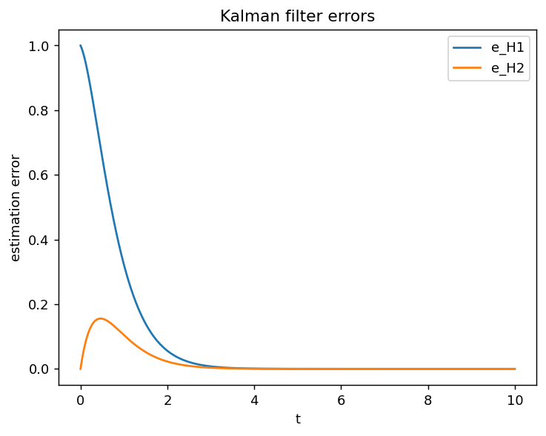

Changed L (stability preserved)
The observer gain L is slightly changed while the error dynamics stay stable, and experiment 2 is repeated with the same simulation time. A non-optimal L degrades the estimation error.
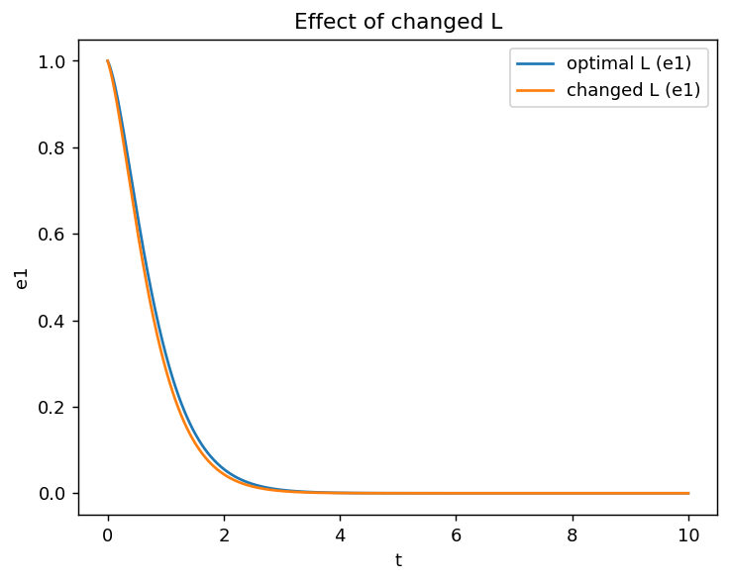

Changed W (symmetric, positive definite)
W is replaced by W=[[8,3.5],[3.5,10]], which is symmetric and positive definite, and experiment 2 is repeated. Larger process noise W raises the gain and the steady-state estimation error.
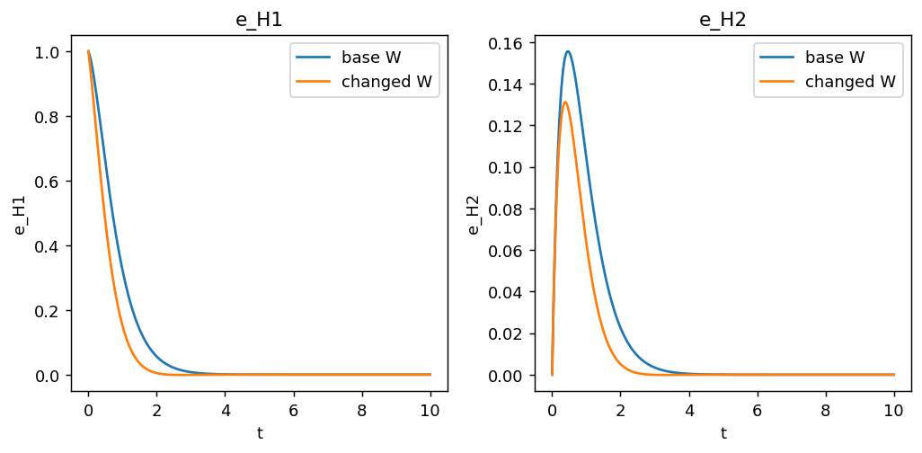

Changed V (positive)
V is replaced by V=1 (positive), and experiment 2 is repeated. Smaller measurement noise V makes the filter trust the measurements more, which reduces the estimation error.
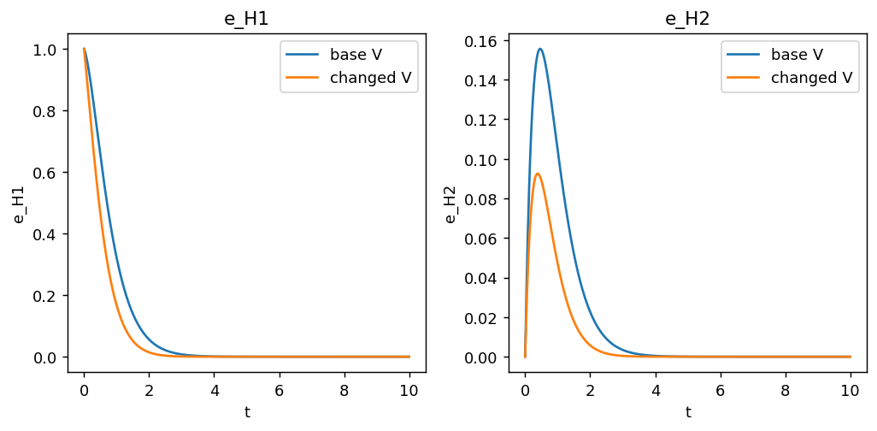

LQG controller
Combining the Kalman estimate with the LQR gain (Q,r from Work 2) gives the LQG controller u=-K x_hat; the closed loop is stable.
K = ['0.2046', '0.4465']
LQG closed-loop eig real parts = ['-1.0942', '-7.6683']
